Required practical activity: Use a low voltage power supply to pass a current through two different salt solutions.
Required Practical Guide – Electrolysis

Aim: Investigate what happens when two different aqueous solutions are electrolysed using inert electrodes.
Notes and guidance
You may wish to have students collect the equipment for this themselves from communal trays at the front of the lab. This will help them to develop their skills of equipment recognition and organisation. However, if this is impractical, ask your technician colleagues if they are able to set up individual sets at student workstations. Ensure each group has sufficient space to work comfortably.

If students are working in groups, encourage them to share responsibilities among one another so each student gets experience with the various scientific techniques and pieces of equipment.

This experiment requires the use of low voltage power supplies. These should be locked so the voltage cannot be turned up to exceed that which is required for electrolysis. Approximately 4V is usually sufficient. If power supplies are not available, battery packs can be used instead.

Speak with your technician colleague in advance of this practical as they may need time to prepare resources. Electrolysis can be done on various scales with petri dishes, beakers, or dedicated electrolysis chambers.
Risk Assessment Notes
A risk assessment must be completed for this practical. The risk assessment should be specific to the class involved and written only by the teaching member of staff. For more guidance refer to CLEAPSS. It is good practice for students to wear safety spectacles during all class practicals and demos.

Ensure that power supplies are locked so they cannot exceed 4V. Liquids should be kept a safe distance from power supplies and any spills should be cleaned up immediately. Copper (II) chloride solution is hazardous. Refer to CLEAPSS hazcards during planning and take care when handling.
Equipment Per Group | Setup Per Group  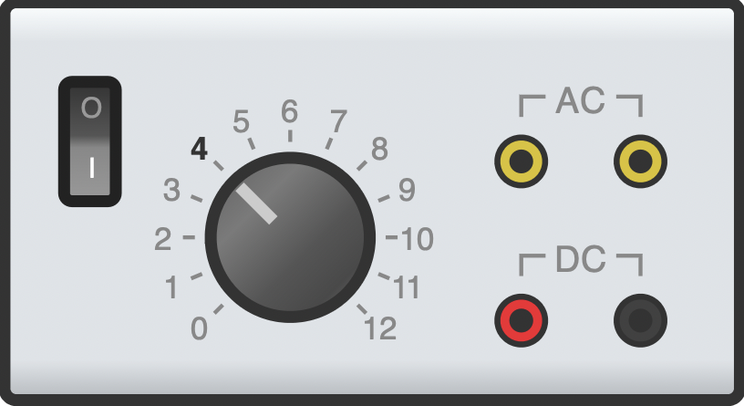  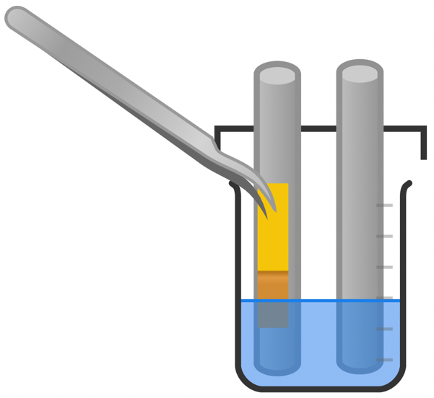  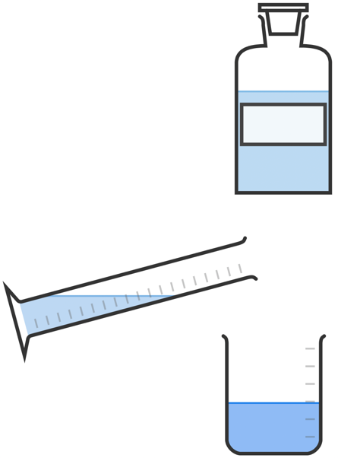  CuCl₂
Apparatus:
- Electrolysis cell or 100ml beaker plus prepared petri dish lid (see later section)
- Two graphite electrodes
- Two crocodile clips
- Two 4mm leads
- Low voltage power supply (4V)
- Blue litmus paper
- Forceps

Chemicals:
- 0.5M copper (II) chloride solution
- 0.5M sodium chloride solution

Method |  | Questions To Ask Students During The Practical
- Pour 50 ml of copper (II) chloride solution into the 100 ml beaker.  - Place the petri dish lid on top of the beaker and insert the graphite rods ensuring they do not touch one another.  - Connect the two graphite rods to the power supply using the crocodile clips and 4mm leads.  - Set the power supply to 4V and switch it on.  - Monitor the activity at the two electrodes and record any observations in your table.  - Hold a small piece of blue litmus paper in the forceps and position this in the solution next to the positive electrode (anode). Use any change in its appearance to identify the element formed and record this in your table.  - Empty the electrolysis cell and rinse. Use new electrodes to repeat the experiment with sodium chloride solution. |  | - What is the name given to the positive electrode? (The ‘anode’.)  - What is the name given to the negative electrode? (The ‘cathode’.)  - Why is it important to ensure the two electrodes do not touch one another? (This would create a short circuit and no electricity would pass through the aqueous solution.)  - Why is it important to rinse the equipment before repeating the experiment with sodium chloride solution? (To ensure there is no contamination of the pure sodium chloride solution with copper chloride solution.)
Alternative Methods/Computer Simulations |  | Clearing up
It is possible to carry out electrolysis with a variety of pieces of equipment. See the Electrolysis Cell section of this guide for more information on options there.  As an extension, you may wish to allow students to experiment with the electrolysis of other solutions. Ensure you research and trial these experiments beforehand to avoid any hazardous situations being created.  Many computer simulations of electrolysis with excellent animations and diagrams that show the details of the process. Consider incorporating one of these into a lesson before carrying out the practical. |  | It is important that equipment is returned to the prep room in good order. If safe to do so, rinse used equipment and put it in the used equipment tray. If the trays arrived on a trolley, students must return all trays and equipment to that trolley. Anything dirty needs to be placed into a separate container for washing up. Never put dirty equipment back into a tray with clean equipment.
Results Table
Solution | Positive electrode (anode) |  |  | Negative electrode (cathode)
Solution | Observations | Element formed | State | Observations | Element formed | State
Copper (II) chloride
Sodium chloride

Sample Results Table
Solution | Positive electrode (anode) |  |  | Negative electrode (cathode)
Solution | Observations | Element formed | State | Observations | Element formed | State
Copper (II) chloride | Bubbles of gas  Bleaches blue litmus paper white | Chlorine | gas | Brown/red solid coating on rod | Copper | solid
Sodium chloride | Bubbles of gas  Bleaches blue litmus paper white | Chlorine | gas | Bubbles of gas (more rapid production) | Hydrogen | gas

Electrolysis Cells
This experiment can be completed successfully by balancing two graphite rods in a beaker of solution so that they do not touch one another. However, this can prove fiddly to set up, so it is advisable to at least prepare a holder for the rods. This can be done by making two holes in the lid of an appropriately sized petri dish. A hot soldering iron works well for this task. Alternatively, rods can be inserted into a two-hole bung and held in place with a retort stand and clamp.

Dedicated electrolysis chambers are available for purchase from many scientific suppliers. These consist of a cylinder of metal that can fit over a two-hole bung with protruding electrodes. The benefit of these is that they require much less solution per experiment, and also allow for easy collection of any gases generated via upturned ignition tubes over each of the electrodes.

A microscale electrolysis chamber can be constructed in a small petri dish, or electrolysis can be carried out on a large drop of liquid on a laminated surface. Paperclips can be used in place of electrodes if graphite rods are not available, but these will not show the build-up of solid copper as well as carbon will.

Technician Notes
Ensure the solutions you provide are free from contamination and the equipment is as clean as possible.

Discuss this practical with the class teacher ahead of time. Ensure they have considered the risks of this practical and are confident with the techniques used. If necessary, provide them with the appropriate CLEAPSS so they are comfortable with the chemicals to be used and how to use and dispose of them safely.

